A Mini Project Report

on

“Recruitment Process system”

Third Year of Engineering

In

Information Technology Engineering

By

Abhishek Pandita (Roll no:6)

Siddeshwari Patil (Roll no:7)

Abhijet Pawar (Roll no:8)

Saakshi Pawar (Roll no:9)

Megh Poddar (Roll no:10)

**Choice Based Credit Grading System with Holistic Student Development**

**(CBCGS-H 2019)**

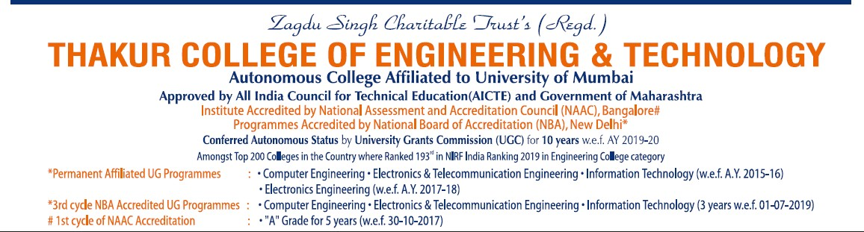

**CERTIFICATE**

This is to certify that Mr. Abhishek Pandita, Ms. Siddeshwari Patil, Mr. Abhijet Pawar, Ms.Saakshi Pawar, Mr. Megh Poddar of Third Year “**IT”** Engineering at Thakur College of Engineering and Technology, have satisfactorily completed the requirements of the PROJECT under Employability Skills Development Programme - 2020 while working on “**Recruitment Process System”**

**Mr. Namdeo Badhe**

**T&P Coordinator**

**Mr. Amol Dapkekar**

**Training Coordinator**

**Dr. Zahir Aalam**

**Professor (TPO)**

**Dr. B. K. Mishra**

**Principal**

**Internal Examiner:**

**Signature with Date: ……………..**

**Name: ……………………………..**

**External Examiner:**

**Signature with Date: …………..**

**Name: ………………………….**

PLACE: Mumbai

DATE:31st July,2020



**INDEX**

|  |  |
| --- | --- |
| **Sr No** | **Title** |
|  | Executive Summary |
|  | Problem Statement |
|  | Description |
|  | Finding |
|  | Implementation |
| 6. | Result & Discussion |
| 7. | Impact Study |
| 8. | Conclusion |
| 9. | References |

**1.EXECUTIVE SUMMARY**:

* Human Resource (HR)management has become one of the essential functions in an organization. Therefore the HRD has to ensure that the welfare of employees are taken into consideration in their overall tasks.
* Recruitment refers to a process by which potential candidates are selected through venture is gone for building up an online and focal Recruitment Process System for the HR Group for an organization. A few highlights of this framework will make opportunities, putting away Applicants information, Interview process starts, Scheduling Interviews, Storing Interview comes about for the candidate lastly Hiring of the candidate. Reports might be required to be produced for the utilization of HR gathering.

**2.PROBLEM STATEMENT:**

* **The problems faced in web development recruitment by the HR group are attracting top talent, lack of quality candidates, technology misalignment.**
* **Painfully slow decision-making is one of the self-inflicted problems in the recruitment and selection process. Job-seekers are showing little patience for employers who expect them to endure multiple rounds of interviews over the course of several weeks. And in a tight labour market, they don’t have to bide their time. An employer who prolongs the vetting process risks missing out on tapping into the best of a shrinking talent pool.**

**3.DESCRIPTIONS:**

* The project will focus on admin creates a job applicants profile, creates a CVV, education and experience profile for applicant selection.

Employee Management System Project in PHP with Source Code

* ****Admin Module****

Admin can manage all employee records, edit user personal details, work exp. details, and work exp. details.

* ****Admin Login****

For admin security features it uses session.

* ****Employee Module****

This system has an employee module that can monitor attendance, manage payroll, and other HR features.

* ****Employee Management****

They Can add or edit own information such as work experience details, educational background, and the likes.

**4.FINDINGS:**

* Mention finding from literature survey and existing projects that you have studied.

**Employee recruitment system project** is useful for small sized and large sized companies for recruiting new members for company. This is a automated process where candidates resumes are updated and interview details are stored  and documents information are submitted and employee payroll information, joining dates..etc  are part of this system.  For every company recruitment process is a time taking process and large number of resources are required, using this system will save time, reduce cost and accurate method are followed for recruiting genuine candidates.

Employees information are stored in different categories based on their experiences and training are provided for fresher for improving knowledge and skills to make him fit for job.

**5.IMPLEMENTATION:**

* Software used in project is XAMPP
* We have used scripting Language as HTML, CSS,PHP



**Flowchart of proposed system**

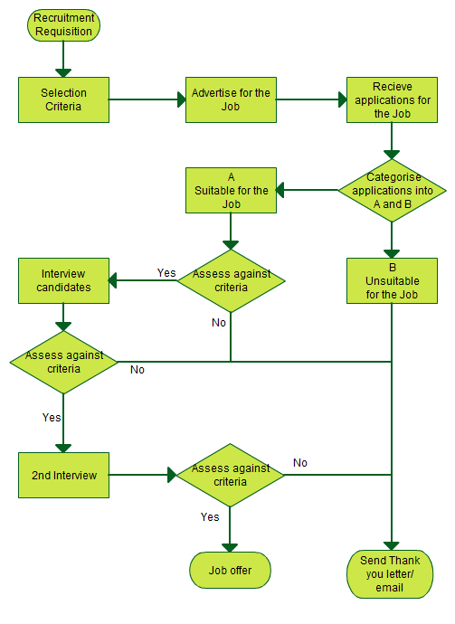

**6.RESULT & DISCUSSION:**

On the basis of the conducted research, we can conclude that the use of modern technologies in the recruitment and selection process is not only a guarantee of completion with the intended effect of a given project, but also causes a real improvement in the recruitment process, which allows, in particular for the business sector to reduce costs and time.

**7.IMPACT STUDY:**

The system will help recruiters in recruiting the employees.

**8.CONCLUSION:**

It has been shown that companies can increase the efficiency of the recruitment process and significantly cut costs, by integrating e-recruitment systems in their HR management infrastructure.

**9.REFERENCE:**

* [1] HUMAN RESOURCE MANAGEMENT MANUAL by The Governor and the
* 2000 session of the Virginia General Assembly approved the Commission’s
* recommendation to develop a new Compensation Management System for
* employees covered by the Virginia Personnel Act.
* [2] Marchington R., Human resource management, Blackwell publishing, 2006.
* [3] http://www.delicious.com/manchestercareers/HRandRecruitment, last accessed
* on 06.03.2011
* [4] Tountopoulos V., Diamantakou K., Sarris N., Koutlis D., Brown R.,
* Requirements Identification and Analysis, 2007
* [5] Lievens F. and Harris M. M., Research on Internet Recruiting and Testing:
* Current Status and Future Directions, 2003.
* [6] The Public Appointments Service, e-Recruitment Practices and trends in
* Ireland, first published in 2006.
* [7] Furtmüller E., Wilderom C. and Dick R. V., Sustainable e-Recruiting Portals.